**Hexaware SQL Coding Assessment**

Date : 19-06-2025

1. Update refrigerator product price to 800.

update products set price =800 where name = 'refrigerator';

select * from products;

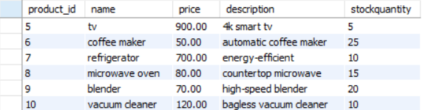  
  
 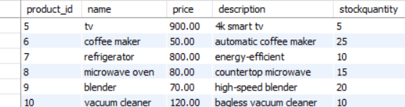

1. Remove all cart items for a specific customer.  
     
    delete from cart where customer_id =9 ;

select * from cart;  
  
 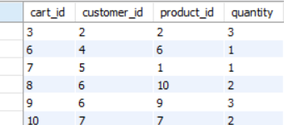

3. Retrieve Products Priced Below $100.  
  
 select * from products where price < 100;  
  
 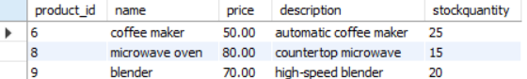

4. Find Products with Stock Quantity Greater Than 5.   
  
 select * from products where stockquantity > 5;  
  
 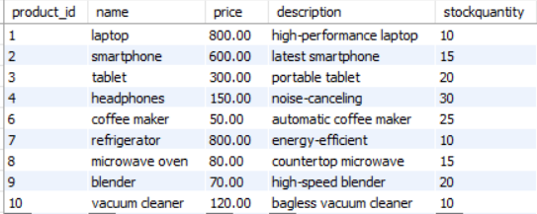  
  
5. Retrieve Orders with Total Amount Between $500 and $1000.   
  
 select * from orders where total_price between 500 and 1000;  
  
 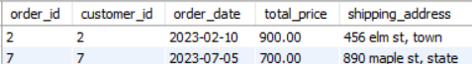  
  
  
6. Find Products which name end with letter ‘r’.   
  
 select * from products where name like '%r';  
  
 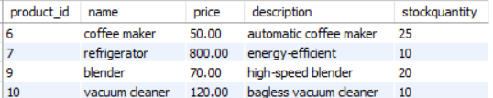

7. Retrieve Cart Items for Customer 5.   
  
 select * from cart where customer_id = 5;

  
  
  
  
  
  
  
  
  
  
  
8. Find Customers Who Placed Orders in 2023.  
   
 select distinct c.customer_id, c.name from customers c

join orders o on c.customer_id = o.customer_id

where year(o.order_date) = 2023;

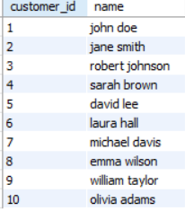  
  
  
 9. Determine the Minimum Stock Quantity for Each Product Category.   
  
 select name, min(stockquantity) as min_stock

from products group by name;

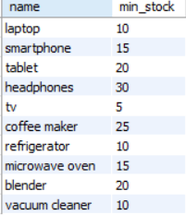  
  
  
10. Calculate the Total Amount Spent by Each Customer.   
  
 select customer_id, sum(total_price) as total_amount_spent

from orders group by customer_id;

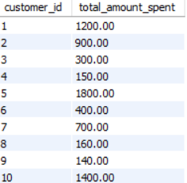

11. Find the Average Order Amount for Each Customer.  
  
 select customer_id, avg(total_price) as average_order_amount

from orders group by customer_id;

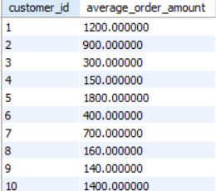

12. Count the Number of Orders Placed by Each Customer.   
  
 select customer_id, count(*) as order_count

from orders group by customer_id;

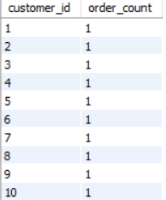  
  
13. Find the Maximum Order Amount for Each Customer.  
  
 select customer_id, max(total_price) as Maximum_order

from orders group by customer_id;

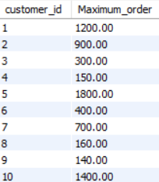

14. Get Customers Who Placed Orders Totaling Over $1000.   
  
 select customer_id from orders group by customer_id

having sum(total_price) > 1000;

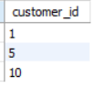  
  
15. Subquery to Find Products Not in the Cart.   
  
 select * from products where product_id   
 not in (select distinct product_id from cart);

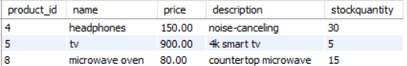  
  
16. Subquery to Find Customers Who Haven't Placed Orders.   
  
 select * from customers where customer_id

not in (select distinct customer_id from orders);

  
  
 After adding a new roe with customer_id = 11,



17. Subquery to Calculate the Percentage of Total Revenue for a Product.  
  
 select p.name,

round(sum(o.total_price) * 100.0 / (select sum(total_price) from orders), 2)

as revenue_percentage

from orders o **join** products p on o.order_id = p.product_id  
 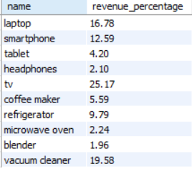

18. Subquery to Find Products with Low Stock.   
  
 select * from products where stockquantity < 10;



19. Subquery to Find Customers Who Placed High-Value Orders.

select distinct c.customer_id, c.name from customers c

join orders o on c.customer_id = o.customer_id

where o.total_price > 1000;

